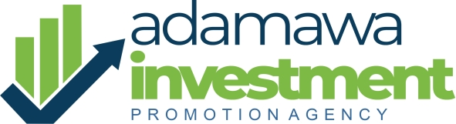
REPORT ON THE VISIT TO HASKE AND WILLIAM RICE MILL COMPANY
Date of Visit: 19th Nov. 2024
Location: Along New Demsa Road Demsa LGA, Adamawa State.
Visitation Team:
- Coordinator, Adamawa State Investment Promotion and Public-Private Partnership Coordinating Unit (ADIPA)
- Head of Investors Relations, ADIPA
- Head of Public-Private Partnership, ADIPA
Introduction
The visit commenced with a meeting between the management team of Haske and William (H&W) Rice Mill Company and the ADIPA delegation. The session began with self-introductions and a clear outline of the purpose of the visit.
The Coordinator of ADIPA provided an overview of the agency's core mandate, emphasizing its role as a government facilitator to promote investment and public-private partnership and also, support investors in areas such as utilities, financing, community engagement, and resolving other operational concerns.
Engagement with H&W Management
The Managing Director of H&W Rice Mill expressed gratitude for the visit and offered insights into the challenges faced by the company since its establishment. He highlighted the absence of government support and detailed specific challenges, including:
- Procurement of raw materials
- Working capital constraints
- Difficulty accessing development bank facilities (e.g., NIRSAL and Bank of Industry)
The MD directed the Production Manager to elaborate on operational issues.
Operational Overview and Challenges
The Production Manager provided a snapshot of the company’s operations:
- The mill processes 1,200 bags of rice daily.
- Expansion plans are in place to establish Phase 2 of the mill.
However, challenges affecting expansion and efficiency include:
- Raw materials shortages
- High energy costs
- Insufficient financing for scaling operations
The Production Manager noted that the Phase 1 utilization rate declined from 85% in 2022 to 65% currently.
Feedback and Suggestions
- The coordinator suggested focusing on maximizing the utilization of Phase 1 (90%-100%) before proceeding with expansion to Phase 2.
- On financial constraints, the MD revealed that the company relies on both equity and commercial bank loans with high interest rates, though efforts are underway to secure a better facility from NIRSAL or the Bank of Industry.
The coordinator assured the team that ADIPA would facilitate discussions with credible financial institutions to secure favorable financing options. A comprehensive list of the company’s support needs was requested by the agency.
Recommendations and Additional Discussions
- The Finance Manager emphasized the importance of government investment in dams across the state to enhance irrigation farming, which would, in turn, secure raw material supplies for milling operations.
- The Head of Investor Relations inquired about employment figures. The company reported creating 200 direct jobs.
Conclusion
The visit highlighted key areas where government intervention and collaboration could significantly enhance the operational efficiency and growth prospects of H&W Rice Mill. ADIPA reaffirmed its commitment to addressing the company’s challenges and facilitating sustainable solutions.
The meeting concluded with a strong understanding of mutual collaboration and the expectation of a detailed support request from H&W Rice Mill Company.

Prepared By:
Zachariah T Kwada
Head Investors Relations
ADIPA

